**City of LA - Data Science for Good - Kaggle Competition**

**URL**: <https://www.kaggle.com/c/data-science-for-good-city-of-los-angeles>

**Description of promotions in job bulletins**

With your structured version of the job bulletins, you should be able to directly connect a job class to any other job classes that are explicitly mentioned as a prerequisite for application (an **explicit promotional pathway**), as they will be clearly identified in each row of the output. For instance, the text of the description for Senior Systems Analyst states the requirement of “Two years of full-time paid experience in a class at the level of Systems Analyst.” In this case, the lower job class of Systems Analyst is explicitly mentioned in the description for Senior Systems Analyst. The ability to promote between these job classes is thus stated explicitly.

Note that you will **not** be evaluated on the extraction of **implicit promotional pathways**, whichare promotions that are allowed by the job bulletins’ qualitative descriptions of duties in one class that happen to satisfy the requirements of another class. For instance, the job class of Senior Administrative Clerk has a requirement of “One year of full-time paid office clerical experience.” Based on the job bulletin for the class of Administrative Clerk, we can infer that an employee who has worked for one year as an Administrative Clerk is eligible for a promotion to Senior Administrative Clerk; however, this inference relies on our semantic understanding of “clerical experience,” as well as our knowledge that employees in the class of Administrative Clerk perform clerical work. In this case, the lower class (Administrative Clerk) is not mentioned explicitly in the section titled “PREVIOUS REQUIREMENT(S)/MINIMUM QUALIFICATION(S)” of the bulletin for the higher class (Senior Administrative Clerk); the promotion must be inferred using textual analysis. Although you will not be evaluated on the identification of implicit promotional pathways, competitors are nonetheless invited to explore and report on methods for completing this task.

From the combination of explicit pathways, you can ultimately construct a directed graph that represents all the promotional pathways that an employee can traverse from a given job class, where each node in the graph represents a job class, and each directed edge represents a promotion from one job class to another. For example, the database would encode the fact that an employee can promote from the job class of Systems Analyst to the job class of Senior Systems Analyst (see the diagram below).

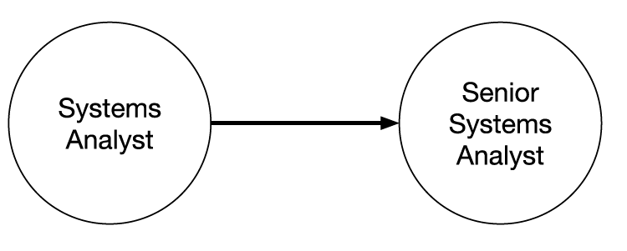

All such promotions could thus be represented in a single directed graph, representing all the City’s job classes and the allowable promotions between them. You are invited to explore ways to visualize this directed graph.

Your kernel should structure all explicit pathways. The structured data that you derive should also allow you to programmatically identify specific employees who are eligible for specific promotions, assuming that you’d have access to a database that contains each employee’s current job class and their duration of employment. For example, given the knowledge that Jackie has been a Systems Analyst for 2.4 years, your system should be able to alert Jackie to the fact that she is now eligible for a promotion to Senior Systems Analyst. If a given promotion requires more than just a number of years of employment in a specific class — e.g., if an advanced degree is also required — then your system should be able to alert Jackie not only that she’s met the years-of-experience requirement but also that the advanced degree is also required for the promotion. If an employee is eligible to promote to multiple job classes, this fact should be identified as well.